LEADER TRAINING PROGRAM APPLICATION: 2021-2022

To apply, email this application to harvardoutingclub@gmail.com
by 11:59 PM on Sun Sept 12!

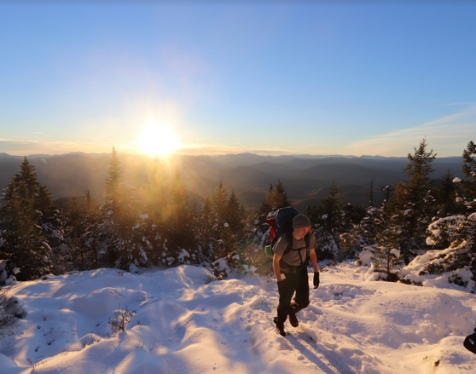
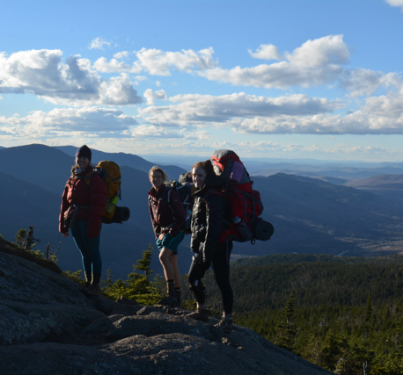
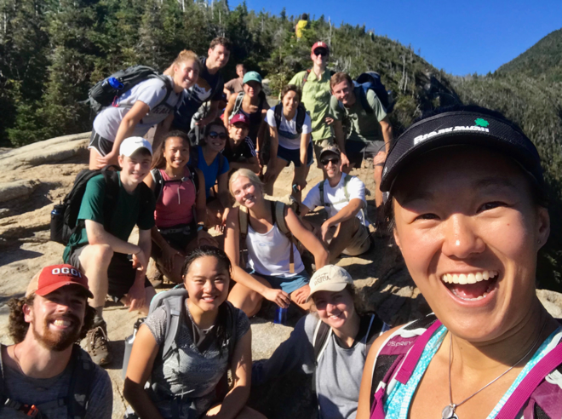

Before you get started, please make sure you’ve read and understand the following.

What is the Harvard Outing Club (HOC)?

We are Harvard’s main outdoor recreation club! Founded in 1939, HOC exists purely to help the Harvard community get outside and have fun in the outdoors. So whether we’re hiking, backpacking, camping, cross-country skiing, snowshoeing, or biking, we want you to come along! We both run trips and loan gear (as well as host on-campus events like square dances, rock climbing nights, outdoorsy speakers, and movie screenings).

What’s the difference between being a member and being a leader?

There are two ways to be involved with HOC: membership and leadership.

Any Harvard affiliate can be a member! For a $20 fee that’s good for six months, members are able to come on trips led by our leaders. Members can also rent from our extensive collection of outdoor gear. It’s as easy as signing up for our email list, which you can do here.

If you’re looking to get significantly more involved, leadership is a great option. Many leaders say that applying was one of the best decisions they made at Harvard.
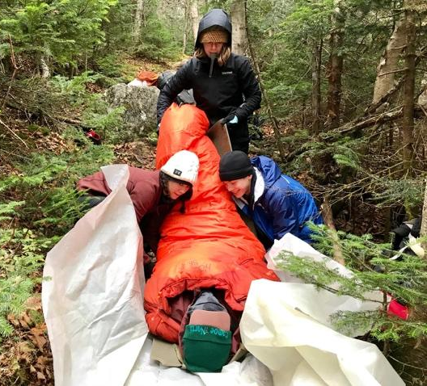
The leadership application (this thing right here) is only open to undergraduates and is only open in the fall. Leader trainees go through a full-year training process that includes Wilderness First Aid (WFA) certification. Upon successful completion of this process, leaders become eligible to lead trips of their own.

Please note that we offer full financial aid, no questions asked, for the costs of both membership and leadership.

Why can you only accept a limited number of leaders?

Because our training process is so involved – in terms of skills development, time, and money –there is a financial and logistical ceiling to the number of applications we can accept. We anticipate taking on a class of 15-20 trainees. Even if not as a leader, we hope you’ll get/stay involved with the club and find time to enjoy the outdoors!

What if I don’t have outdoors experience?

We do value safety and the role that experience plays in shaping good judgment. But we also trust our ability to teach outdoors skills and share them with new people. There’s a reason our training process takes place over the course of the entire school year. We’ll take our time teaching you what you need to know, even if you don’t have outdoors experience or haven’t considered yourself an “outdoorsy person” in the past. If being a HOC leader interests you, we strongly encourage you to apply!

How can I learn more?

- Explore our website (harvardoutingclub.org)
- Check out our Facebook and Instagram (@harvard_outing_club)
- Email us (harvardoutingclub@gmail.com)!
- Come to our open houses! SUN Sept 5 (3-5pm), and WED Sept 8 (7-9pm), and SUN Sept 12 (3-5pm) Room 256 in the SOCH.

Good to go? The application starts below.

I. Basic Information

Name (first and last):

Class Year:

Birthday (mm/dd/yy):

Phone Number:

Email Address:

HUID #:

HUDS ID (bottom back of your ID after CC-): 60641101________

(Anticipated) Concentration:

Dorm/House:

Home State/Country:

II. Important Dates

Leader training is a yearlong process, with training heavily concentrated in the fall. We’ll be flexible in terms of scheduling where possible, but we take our training seriously and want to make clear that we expect attendance at all of the following:

- Five 1/1.5-hour skills sessions: Wednesday nights from late September thru October
- A 16-hour Wilderness First Aid (WFA) training course: weekend of Sept 25-26
- An overnight fall training trip on ONE of the following weekends: Oct 9-10, Oct 15-17, Oct 22-24, or Oct 29-31
- Leader Cabin Weekend: Oct. 1-3 (*optional though highly encouraged*)
- An overnight winter training trip: February/March TBD
- A half-day community-wide skills session: Late spring TBD
- Two required office hours with our Gear Managers

III. Short Response Questions

Please write a 1-2 paragraph response to each of the following.

- Write a short bio of yourself so we can get to know you. Take a look at the leader bios on our website at harvardoutingclub.org/our-leaders/ for inspiration. Have fun with it!

- What do the outdoors mean to you? While this question sounds cheesy, we are interested in understanding why you go outside.

- Why do you want to be a HOC leader? What do you feel HOC brings to Harvard and what do you hope to get out of the training?

- Describe a situation in which you made a difficult decision. What factors did you consider? Are there other factors you wish you had considered? Take us through your thought process. The decision does not have to be a monumental one, or related to the outdoors.

IV. Shorter Response Questions

- Besides leading trips, what other aspects of club leadership (managing our gear, planning events like square dance or first aid classes, etc.) appeal to you? What types of events would you like us to put on that we do not already?

- List the other extracurricular activities you anticipate for the coming year and include the time requirements for each.

- Did you apply to be a leader last year? If yes, what experiences have you had in the past year that you believe change your application?

V. Outdoor and Leadership Experience

- Tell us about a memorable outdoors experience from the past five years. Think outside the box! Anything outside, no matter how unconventional or unstructured, is important to us.

- List any leadership experience (formal or informal) you’ve had.

Dates | Role | Description

VI. Ideal Outdoors Trip

Imagine you are planning a day trip from Harvard. What kind of trip would you lead? Your trip can be somewhere nearby, like most HOC trips are, but you are not limited to New England. From hiking Mt. Katahdin to riding the swan boats in Boston Common to going to an animal sanctuary, if you can dream it, we’re all ears. You should not feel obligated to do any research for your answer – you can choose something that you’d like to do! Please explain your choice.

VII. Bonus

What types of trips do you wish we did and/or what new trips would you want to bring to the club? We usually lead hiking trips, although we also have kayaking, snowshoeing, cross-country skiing, biking, and trail running.

VIII. Anything Else?

Please tell us anything else you’d like us to know about you, any ideas you have for our organization, or any hopes and dreams for the future!

Thank you!

We are so excited that you’ve applied to be a leader! Once we’ve read over the written applications, we’ll be interviewing a select number of applicants. Whether or not you’re selected for an interview, you will receive an update from us the night of Thurs Sept 16.

If you are selected, we will have interviews the weekend of Fri Sept 17-Sun Sept 19. Final decisions will be released early the following week.

Thank you for taking the time to apply – we promise to repay it with a careful reading of your application. Again, whether or not you are selected, we hope you will continue to cultivate a love of the outdoors and join us on the trails this year!

